**For popping anything in JS console in web browser:**

alert(“whatever you want as alert”)

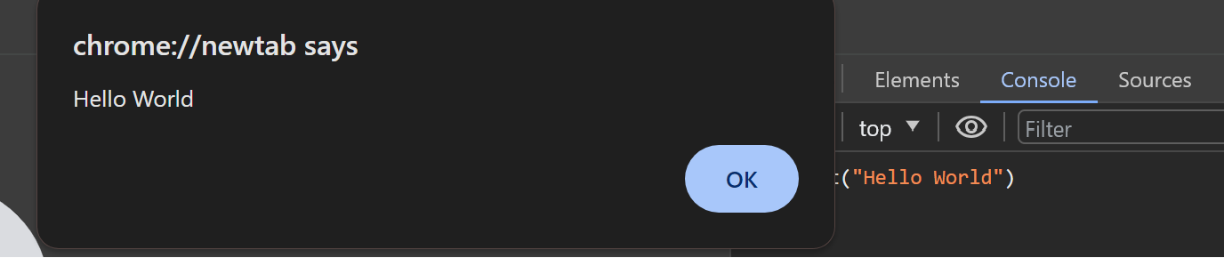

**For commenting**

// statement

**BASIC DATA TYPES:**

* Numbers : Integers, Floating number, Negative numbers, etc (Every number fall under this data type.
* String:

“….”

for concatenation - “..” **+** “…”

* Boolean: True or False
* Undefined
* Null

**To clear console**

console.clear() in chrome browser

clear() in mozilla browser

**To get length of a string:**

string.length

**ESCAPE CHARACTERS**

“\n” : next line

“\t” : act as tab for spacing in string or sentence

**VARIABLE**

var variable_name = value;

Eg.- var Bank_Account=100;

We can define null character also to the variable.

Eg- var x=null;

**To print anything**

console.log(variable/string)

**prompt()**

The Javascript Window prompt() method is used to display a dialog box with an optional message prompting the user to input some text. It is often used if the user wants to input a value before entering a page. It returns a string containing the text entered by the user, or null.

Eg.- var age=prompt(“Enter you’r age”)

